**6. Change the native VLAN on a trunk port. Test for VLAN mismatches and troubleshoot.**

**Setting Up:**

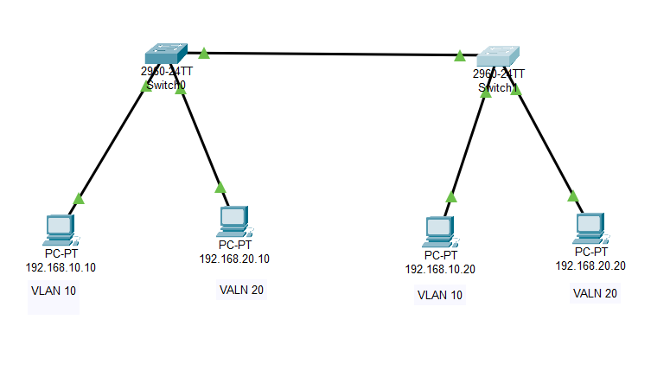

**The Native VLAN is in the default VLAN 1 in 1st switch:**



**Changed the Native VLAN to VLAN 99 in 1st switch:**



**The Native VLAN is still in the default VLAN 1 in 2nd switch:**



It shows the mismatch error:

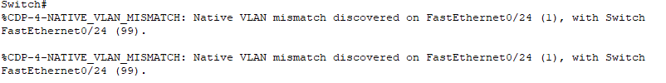

**Troubleshoot the Mismatch:**

Changing the native VLAN in switch 2 to VLAN 99



Now, the mismatch got fixed. We can communicate between LAN by inter routing.